- Where is the project located? Generally South of Highway 24 and East of 21st Street in Southwest Colorado Springs, as depicted in the map below.
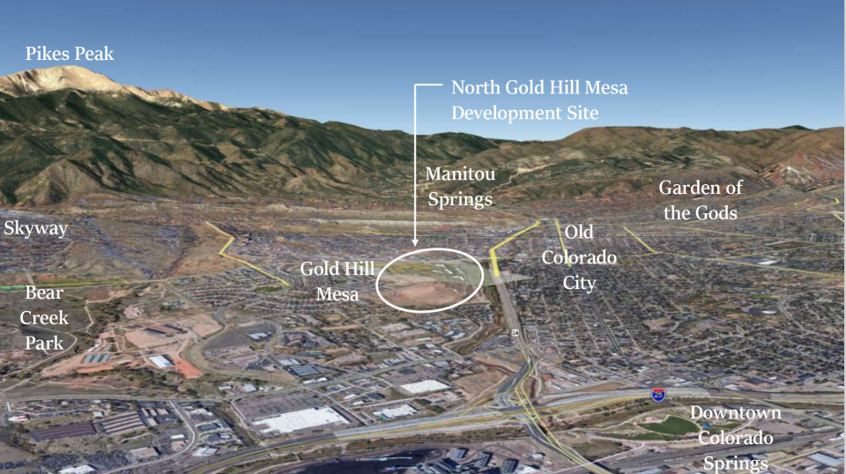
- What is the size of the parcel(s) for the project? Approximately 91.5 acres.
- What is the intended development program (square feet by use)? Existing and proposed zoning?
It is anticipated that the area within the Urban Renewal District will be comprised of approximately 31 acres of residential (attached/detached single family dwellings), approximately 16 acres of commercial area and approximately 44 acres of open space.

Approximately 30 acres of the land within the Urban Renewal District is in the process of being rezoned to Traditional Neighborhood Development (TND); approximately 53 acres, which comprises the primary commercial element of the development, is zoned today as Planned Business Center (PBC) and will remain in that designation, approximately 5 acres is in the process of being rezoned from TND to PBC, and approximately 4 acres that will remain TND.
- What is the development time frame for the project? What phase in the City’s Land Use Review Process is the project within? Will it be phased? There are currently multiple applications in process with the City’s Land Use Review Department, including a Zone Change / Concept Plan application for the entirety of the area within the Urban Renewal District. Said application has been approved at the August 19, 2021 Planning Commission meeting and will go to City Council in September.

The project will be phased, with the Filing 11 Development Plan currently in process with the City of Colorado Springs. We will thereafter submit the Filing 12 Development Plan application, followed by the Filing 13 Development Plan application approximately 3 – 9 months thereafter.
- What is the entity that is doing the project and is it the entity that will be applying for URA funds? AIPA Colorado Investments, LLC or its assigns.
- What is the proposed revenue sharing for the project, total cost and expected return to the developer? Total estimated cost of the project is approximately $250M with an anticipated return of 8-12%. This includes the horizontal development work, hotel vertical costs, multifamily vertical costs, and retail vertical costs, all of which the developer intends to incur.

We are looking for the full increment from the URA.
- Does the project envision utilizing property tax, sales tax and/or private property tax increments? Yes, the development envisions utilizing property tax, sales tax and private property tax increments.
- What private developer funding is being allocated to the project and what is the financing schedule and developer’s source of funds. The developer and/or its affiliates intend to fund the horizontal development work that is necessary to prepare the land for the areas of respective use (i.e., residential or commercial). It is anticipated that all or a portion of its expenditures may be reimbursed pursuant to bond issuances within the Urban Renewal Area.
- What is the developers experience with TIF, urban renewal and operations? The developer has experience with TIF and the Colorado Springs Urban Renewal Authority for the existing Gold Hill Mesa property. Both the top of the Mesa within Gold Hill Mesa and the area subject to future development are within an active Urban Renewal District.
- Does the project work without tax‐increment financing? What would be different without the use of TIF? No, the blighted nature of the site has made this project cost prohibitive for productive development without full increment financing through the URA. Unfortunately, due to unforeseen delays, many of the years on the existing agreement between the developer and URA have already been exhausted with minimal benefit to the area subject to development.
- How many housing units will the project provide? Affordable? We are estimating the number of dwelling units to be between 550 and 700 dwelling units.
- What are any known environmental conditions or hazardous materials on site? The real property subject to development is the location of the former Golden Cycle Mill, which deposited tailings that cover approximately 50-60 percent of the surface area of the property. The developer, in accordance with the Colorado Voluntary Cleanup and Redevelopment Act, C.R.S. 25-16-301 to 311, prepared and submitted to the Colorado Department of Public Health and Environment (CDPHE) a Voluntary Cleanup Plan (VCUP) that was approved by CDPHE on December 20, 2002. The developer will continue to comply with the state-approved VCUP throughout the development process.
The following are anticipated Urban Renewal Board Questions in which the developer should be prepared to answer when considering a project for Urban Renewal designation:
- What is the public benefit/purpose of this project and how will its development benefit the neighborhood/area, city districts and/or county/state? The developer’s goals include, but are not limited to the following:
- Reinvigorate a substantial area of land within the City that historically has been an area of blight.
- Increase the supply of for-sale and for-rent housing types within the City’s urban core.
- Increase the dining and shopping options for both residents within the Gold Hill communities and the City.
- Create a mixed-use community where residents and visitors are able to access walkable amenities and services.
- Create a music park and ancillary commercial uses which will be an amenity to both the community and City. Given the success of Music on the Mesa, it is clear that there is strong demand among members of the community and great programming available to showcase—the creation of a space designed for this purpose would provide a fantastic amenity to the community.
- How do you foresee the long‐term viability of the development, specifically beyond the URA TIF timeline? The diversity in housing types and sizes that the developer anticipates will be constructed within the Urban Renewal District will create a neighborhood that supports strong retail tenants. The developer anticipates the combination of adjacent uses will make this a wonderful and timeless community.
- What risks does the project pose to the city, county and other districts and how are those risks being mitigated? How will this project impact other Urban Renewal Areas (positively or negatively)? The current and future development represent later-phases of a long-term development of the area; the developer does not anticipate that these additional areas of development will pose risks to the city, county or other districts. With the development of this community, the developer feels that neighboring communities will also benefit from its success.
- How do plans for this project compare to other approved projects or urban renewal areas? Today this project is within an Urban Renewal District. It is one of the last remaining large infill commercial/residential projects on the West side of Colorado Springs.
- How will this project impact/ incorporate current residents and businesses in or near the project area? The construction of new residences and commercial space further expands the housing and business opportunities in the area. Greater numbers of residents will support more businesses and offer wider arrays of amenities to the community at large.
- What considerations have been made in regard to minority or woman‐owned businesses for the project? As the developer continues to develop the project, it is mindful of encouraging and promoting minority and woman-owned businesses.
- How will this project impact public services (transit, police/fire, schools and libraries)? As an infill development, the developer believes the impact on public services is relatively minimal compared to other suburban projects. The developer intends to communicate with those providers to better understand how it may be a positive community partner.
- How will this project impact the tax base surrounding the area? The developer anticipates that this project is unlikely to cause a major impact on the tax base surrounding the area.
- Are you looking to bond, and if so, how do you foresee the bonds of the project being administered? Yes. In addition to the URA tax increment financing, the developer is in the process of creating two (2) Metropolitan Districts and one (1) Business Improvement District. One or more of those entities will issue and administer bonds.
- What considerations have been made for affordable housing with the project? The developer has researched tax credits for affordable housing through CHFA and ultimately has decided not to pursue that option. We anticipate that the residential portions of the project will be comprised of a variety of housing options and price points—both for-sale and for-rent.

